Lab 6

- Answer all of the following questions. Questions are given in bold italics.
- Save all your answers in a file named YourFirstNameYourLastName.doc (or the appropriate file extension).
- Upload this file to Blackboard.

During this lab you will learn the following:

Mathematic Calculations at the command line
Mathematic Calculation in Shell Scripts
Variable Substitution & assignment

- Here is a script to show you how variables are initialised and printed to the screen. Type it in, use chmod if needed to give you executable permissions and run this script.

myname=HAL
myos=Linux
my_lucky_no=5
echo "My name is $myname"
echo "My os is $myos"
echo "My number Lucky number is $, can you see this number?"

My_Kernel=`uname`
My_Kernel_Release=`uname -r`
echo "The kernel of my OS is: $My_Kernel"
echo "Whose release is: $My_Kernel_Release"

Note: Space between uname and –r.
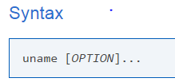
Print certain system information. If no OPTION is specified, uname assumes the -s option (i.e. print the kernel name). More options at uname.

What is printed to the screen in the first 3 echo lines? Fix the bug in the output.
What do you notice from the output of each echo line?

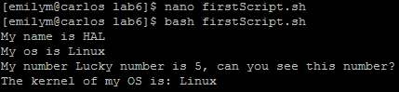

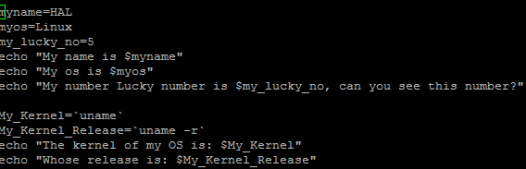

I noticed that the defined variables were placed where the $(variable) was placed.

- Type the expressions below on the command line, note and explain the output for each. If you learn from your mistakes note this as well – it shows you have an understanding of the command line. (Note: if there are spaces make sure you put them in.)

The expressions to type at the prompt are as follows:

expr 1 + 3 = 4
expr 2 – 1 =1
expr 10 / 2 =5
expr 20 % 3 =2
expr 10 \* 3 =30
echo “expr 6 + 3” = expr 6 + 3
echo `expr 6 + 3` = 9

For the last statement note the following points:
- Before expr keyword we used ` (back quote) sign not the (single quote i.e. ') sign.
- expr is also closed with ` i.e. back quote. Also, expr 6 + 3 is evaluated to 9, then echo command prints 9 as sum. If you use double quote or single quote, it will NOT work

- From the command line (not a script) how might you assign a mathematical calculation to a variable name and then output that value.

For example:

Set the variable x = 2.
Now display the value of x.

(Hint : Look at previous script to figure out the answer).

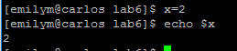

Mathematics Calculation in Shell Scripts
The following script is also useful in showing other ways of variable representation (arrays) and variable arithmetic.

V=abc
echo $V

X=(123 def ghi)
echo ${X[2]}

X=1
Y=2
let Z=$X+$Y
echo
echo $Z
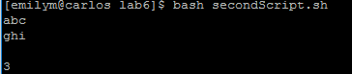
- Type in and run the above script and note the output. What do you think X is in the first instance?
X is an array

Now add to your script so that it adds Z, A and B (create A & B) and stores the result in K. Output the result.

List the contents of your script or attach a screen shot of your script here.
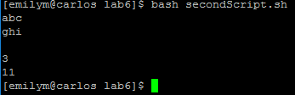

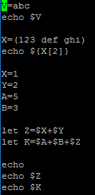
- Write a script that asks for two integer numbers and prints out whether or not they are equal.

List the contents of your script or attach a screen shot of your script here.

Sample output below:

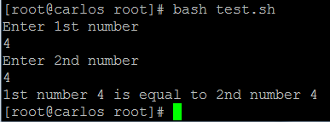

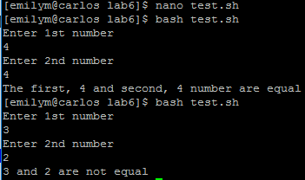
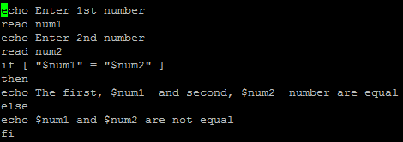

- Type out the following script (minus the comments), it shows how variables are assigned and how variable substitution is used when displaying the variables value: Explain in your own words the output at each stage, i.e., each echo. (Comments in the script below should explain most of it.)

#!/bin/bash
# Variables: assignment and substitution

a=375
hello=$a

#------------------------------------------------------------------------------------------------
# No space permitted on either side of = sign when initializing variables.

# If "VARIABLE =value",
#+ script tries to run "VARIABLE" command with one argument, "=value".

# If "VARIABLE= value",
#+ script tries to run "value" command with
#+ the environmental variable "VARIABLE" set to "".
#------------------------------------------------------------------------------------------------

echo hello # Not a variable reference, just the string "hello".
echo $hello
echo ${hello} #Identical to above.

echo "$hello"
echo "${hello}"

echo '$hello' #these are single quotes
# Variable referencing disabled by single quotes,
#+ which causes the "$" to be interpreted literally.
# Notice the effect of different types of quoting.

hello= # Setting it to a null value.
echo "\$hello (null value) = $hello"
# Note that setting a variable to a null value is not the same as
#+ unsetting it, although the end result is the same (see below).
#------------------------------------------------------------------------------------------------
# It is permissible to set multiple variables on the same line,
#+ if separated by white space.
# Caution, this may reduce legibility, and may not be portable.

var1=variable1 var2=variable2 var3=variable3
echo
echo "var1=$var1 var2=$var2 var3=$var3"

# May cause problems with older versions of "sh".
#------------------------------------------------------------------------------------------------

echo; echo

numbers="one two three"
other_numbers="1 2 3"
# If whitespace within a variable, then quotes necessary.
echo "numbers = $numbers"
echo "other_numbers = $other_numbers"
echo

echo "uninitialized_variable = $uninitialized_variable"
# Uninitialized variable has null value (no value at all).
uninitialized_variable= # Declaring, but not initializing it
# (same as setting it to a null value, as
# above).
echo "uninitialized_variable = $uninitialized_variable"
# It still has a null value.

uninitialized_variable=23 # Set it.
echo "uninitialized_variable = $uninitialized_variable"
unset uninitialized_variable # Unset it.
echo "uninitialized_variable = $uninitialized_variable"
# It still has a null value.

echo
exit 0

